|  |  |
| --- | --- |
| **Astra** | Fecha: 18/05/2020 |
| Revisión: 1.0 |

|  |  |  |
| --- | --- | --- |
| 1.0 | Gonzalo Alonso Escudero Perla | 18/05/2020 |

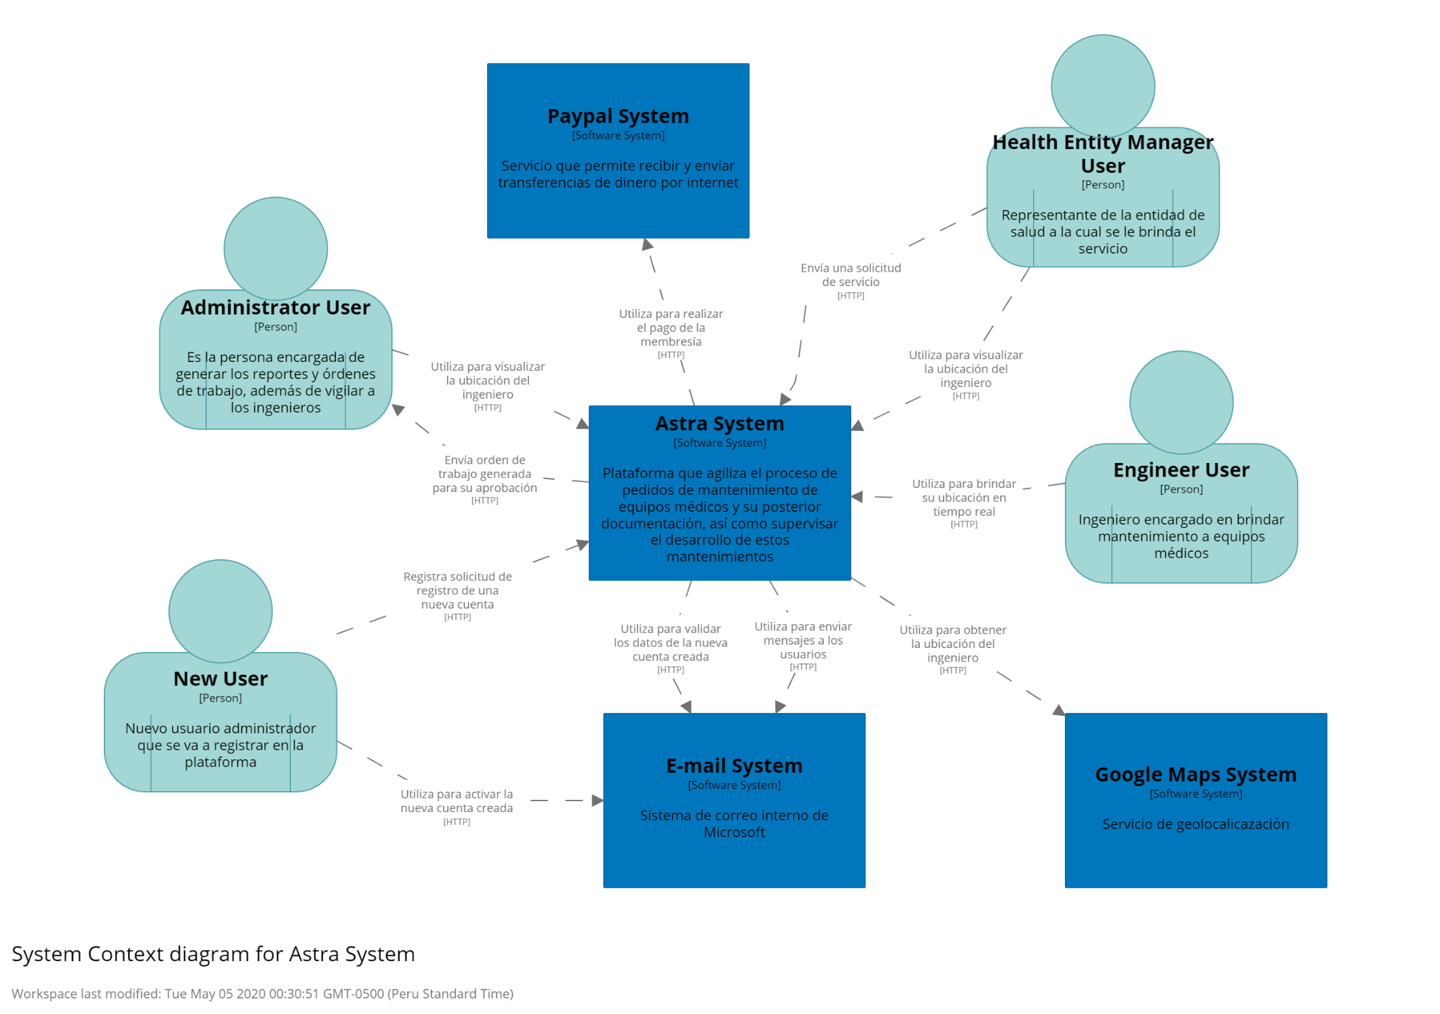**Architecture Overview**

Fuente: Elaboración propia mediante la plataforma Structurizr

#### **Context Diagram Json**

{

"id": 53761,

"name": "Workspace 53761",

"description": "An empty workspace.",

"revision": 6,

"lastModifiedDate": "2020-04-28T00:46:48Z",

"lastModifiedUser": "u201712673@upc.edu.pe",

"lastModifiedAgent": "structurizr-web/1876",

"model": {

"people": [

{

"id": "9",

"tags": "Element,Person",

"name": "Administrator User",

"description": "Es la persona encargada de generar los reportes y órdenes de trabajo, además de vigilar a los ingenieros",

"relationships": [

{

"id": "30",

"tags": "Relationship",

"sourceId": "9",

"destinationId": "11",

"description": "Realiza el pago a través de su sistema",

"interactionStyle": "Synchronous"

},

{

"id": "33",

"tags": "Relationship",

"sourceId": "9",

"destinationId": "1",

"description": "Solicita ubicación del ingeniero",

"interactionStyle": "Synchronous"

}

],

"location": "Unspecified"

},

{

"id": "7",

"tags": "Element,Person",

"name": "Engineer User",

"description": "Ingeniero encargado en brindar mantenimiento a equipos médicos",

"relationships": [

{

"id": "22",

"tags": "Relationship",

"sourceId": "7",

"destinationId": "3",

"description": "Solicita su posición en el mapa",

"interactionStyle": "Synchronous"

},

{

"id": "21",

"tags": "Relationship",

"sourceId": "7",

"destinationId": "1",

"description": "Brinda ubicación a tiempo real",

"interactionStyle": "Synchronous"

}

],

"location": "Unspecified"

},

{

"id": "8",

"tags": "Element,Person",

"name": "Health Entity Manager User",

"description": "Representante de la entidad de salud a la cual se le brinda el servicio",

"relationships": [

{

"id": "32",

"tags": "Relationship",

"sourceId": "8",

"destinationId": "1",

"description": "Envía un solicitud de servicio",

"interactionStyle": "Synchronous"

},

{

"id": "31",

"tags": "Relationship",

"sourceId": "8",

"destinationId": "1",

"description": "Solicita ubicación del ingeniero",

"interactionStyle": "Synchronous"

}

],

"location": "Unspecified"

},

{

"id": "10",

"tags": "Element,Person",

"name": "New User",

"description": "Persona que va a crear una cuenta administrativa",

"relationships": [

{

"id": "12",

"tags": "Relationship",

"sourceId": "10",

"destinationId": "1",

"description": "Envía solicitud de registro con una cuenta externa",

"interactionStyle": "Synchronous"

},

{

"id": "13",

"tags": "Relationship",

"sourceId": "10",

"destinationId": "2",

"description": "Envía confirmación de login",

"interactionStyle": "Synchronous"

}

],

"location": "Unspecified"

}

],

"softwareSystems": [

{

"id": "1",

"tags": "Element,Software System",

"name": "Astra System",

"description": "Facilita la realización de pedidos de mantenimiento y su posterior documentación",

"relationships": [

{

"id": "27",

"tags": "Relationship",

"sourceId": "1",

"destinationId": "8",

"description": "Envía ubicación del ingeniero",

"interactionStyle": "Synchronous"

},

{

"id": "24",

"tags": "Relationship",

"sourceId": "1",

"destinationId": "2",

"description": "Envía solicitud para validar datos del nuevo usuario",

"interactionStyle": "Synchronous"

},

{

"id": "34",

"tags": "Relationship",

"sourceId": "1",

"destinationId": "9",

"description": "Envía orden de trabajo generada para su aprobación",

"interactionStyle": "Synchronous"

},

{

"id": "26",

"tags": "Relationship",

"sourceId": "1",

"destinationId": "9",

"description": "Solicita pago de membresía",

"interactionStyle": "Synchronous"

},

{

"id": "25",

"tags": "Relationship",

"sourceId": "1",

"destinationId": "9",

"description": "Envía ubicación del ingeniero seleccionado",

"interactionStyle": "Synchronous"

},

{

"id": "20",

"tags": "Relationship",

"sourceId": "1",

"destinationId": "7",

"description": "Solicita ubicación del ingeniero",

"interactionStyle": "Synchronous"

}

],

"location": "Unspecified",

"containers": [

{

"id": "6",

"tags": "Element,Container",

"name": "Astra Database",

"description": "Base de datos relacional de Microsoft SQL Server desplegado a través de Azure Cloud Services",

"technology": "Database"

},

{

"id": "5",

"tags": "Element,Container",

"name": "Clenic Mobile Android app",

"description": "Aplicación de Android para el consumo del API RESTful",

"technology": "Mobile App"

},

{

"id": "4",

"tags": "Element,Container",

"name": "Server-side web application",

"description": "Una aplicación web en ASP .NET desplegado en Microsoft IIS",

"technology": "Server-side web application"

}

]

},

{

"id": "2",

"tags": "Element,Software System",

"name": "E-mail System",

"description": "Sistema de correo interno de Microsoft",

"relationships": [

{

"id": "28",

"tags": "Relationship",

"sourceId": "2",

"destinationId": "1",

"description": "Valida los datos de registro del nuevo usuario",

"interactionStyle": "Synchronous"

},

{

"id": "14",

"tags": "Relationship",

"sourceId": "2",

"destinationId": "10",

"description": "Manda solicitud de confirmación de login",

"interactionStyle": "Synchronous"

}

],

"location": "Unspecified"

},

{

"id": "3",

"tags": "Element,Software System",

"name": "Google Maps System",

"description": "Servicio de geolocalicazación",

"relationships": [

{

"id": "23",

"tags": "Relationship",

"sourceId": "3",

"destinationId": "7",

"description": "Brinda ubicación a tiempo real",

"interactionStyle": "Synchronous"

}

],

"location": "Unspecified"

},

{

"id": "11",

"tags": "Element,Software System",

"name": "Paypal System",

"description": "Servicio que permite recibir y enviar transferencias de dinero por internet",

"relationships": [

{

"id": "29",

"tags": "Relationship",

"sourceId": "11",

"destinationId": "1",

"description": "Envía respuesta de pagos de la membresía",

"interactionStyle": "Synchronous"

}

],

"location": "Unspecified"

}

],

"deploymentNodes": []

},

"documentation": {

"sections": [

{

"title": "Appendices",

"order": 7,

"format": "Markdown",

"content": "### Decisions and Alternatives\n\n### Questions and Answers\n\n### References"

},

{

"title": "Introduction",

"order": 1,

"format": "Markdown",

"content": "### Purpose and Scope\n\n### Audience\n\n### Status\n\n### Architectural Design Approach"

},

{

"title": "Glossary",

"order": 2,

"format": "Markdown",

"content": ""

},

{

"title": "System Qualities",

"order": 6,

"format": "Markdown",

"content": "### Performance and Scalability\n\n### Security\n\n### Availability and Resilience\n\n### Evolution\n\n### Other Qualities"

},

{

"title": "Architectural Forces",

"order": 4,

"format": "Markdown",

"content": "### Goals\n\n### Constraints\n\n### Architectural Principles"

},

{

"title": "System Stakeholders and Requirements",

"order": 3,

"format": "Markdown",

"content": "### Stakeholders\n\n### Overview of Requirements\n\n### System Scenarios"

},

{

"title": "Architectural Views",

"order": 5,

"format": "Markdown",

"content": "### Context View\n\n### Functional View\n\n### Information View\n\n### Concurrency View\n\n### Deployment View\n\n### Development View\n\n### Operational View"

}

],

"decisions": [],

"images": []

},

"views": {

"systemContextViews": [

{

"softwareSystemId": "1",

"key": "Astra",

"paperSize": "A5_Landscape",

"animations": [

{

"order": 1,

"elements": [

"1"

],

"relationships": []

},

{

"order": 2,

"elements": [

"10"

],

"relationships": [

"12"

]

},

{

"order": 3,

"elements": [

"11",

"2",

"3",

"7",

"8",

"9"

],

"relationships": [

"22",

"33",

"23",

"34",

"13",

"24",

"14",

"25",

"26",

"27",

"28",

"29",

"30",

"20",

"31",

"21",

"32"

]

}

],

"enterpriseBoundaryVisible": false,

"elements": [

{

"id": "11",

"x": 905,

"y": 95

},

{

"id": "1",

"x": 1015,

"y": 700

},

{

"id": "2",

"x": 1040,

"y": 1230

},

{

"id": "3",

"x": 1835,

"y": 1230

},

{

"id": "7",

"x": 1835,

"y": 605

},

{

"id": "8",

"x": 1790,

"y": 85

},

{

"id": "9",

"x": 200,

"y": 425

},

{

"id": "10",

"x": 180,

"y": 965

}

],

"relationships": [

{

"id": "21",

"vertices": [

{

"x": 1750,

"y": 960

}

]

},

{

"id": "32",

"vertices": [

{

"x": 1405,

"y": 490

}

]

},

{

"id": "20",

"vertices": [

{

"x": 1610,

"y": 825

}

]

},

{

"id": "31",

"vertices": [

{

"x": 1770,

"y": 650

}

]

},

{

"id": "30",

"vertices": [

{

"x": 620,

"y": 430

}

]

},

{

"id": "29"

},

{

"id": "28",

"vertices": [

{

"x": 1470,

"y": 1170

}

]

},

{

"id": "27",

"vertices": [

{

"x": 1575,

"y": 565

}

]

},

{

"id": "26",

"vertices": [

{

"x": 765,

"y": 765

}

]

},

{

"id": "14",

"vertices": [

{

"x": 815,

"y": 1270

}

]

},

{

"id": "25",

"vertices": [

{

"x": 850,

"y": 685

}

]

},

{

"id": "13",

"vertices": [

{

"x": 745,

"y": 1400

}

]

},

{

"id": "24",

"vertices": [

{

"x": 1155,

"y": 1115

}

]

},

{

"id": "12",

"vertices": [

{

"x": 780,

"y": 1020

}

]

},

{

"id": "23",

"vertices": [

{

"x": 2230,

"y": 1105

}

]

},

{

"id": "34",

"vertices": [

{

"x": 710,

"y": 870

}

]

},

{

"id": "22",

"vertices": [

{

"x": 1920,

"y": 1105

}

]

},

{

"id": "33",

"vertices": [

{

"x": 930,

"y": 570

}

]

}

]

}

],

"configuration": {

"branding": {},

"styles": {

"elements": [

{

"tag": "Person",

"background": "#a2d7d5",

"stroke": "#55a3ab",

"shape": "Person"

},

{

"tag": "Element",

"background": "#0077bc"

},

{

"tag": "Container",

"background": "#c2d5e4"

}

],

"relationships": [

{

"tag": "Relationship",

"fontSize": 20,

"dashed": true,

"routing": "Direct"

}

]

},

"terminology": {},

"lastSavedView": "Astra"

},

"systemLandscapeViews": [],

"containerViews": [],

"componentViews": [],

"dynamicViews": [],

"deploymentViews": [],

"filteredViews": []

}

}